NAME:NIRANJANEE B

REG NO.:727721EUCS093

STUDENT INFORMATION PORTAL

1)USE CASE DIAGRAM:

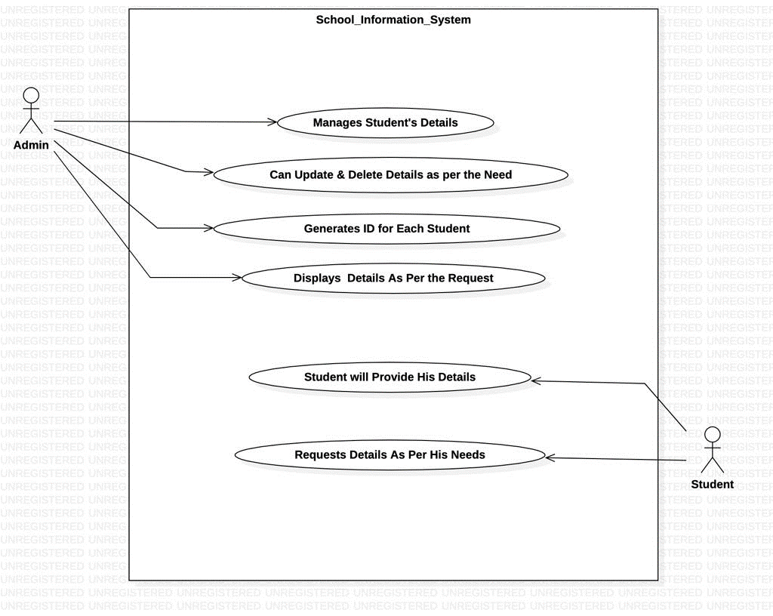

2)CLASS DIAGRAM:

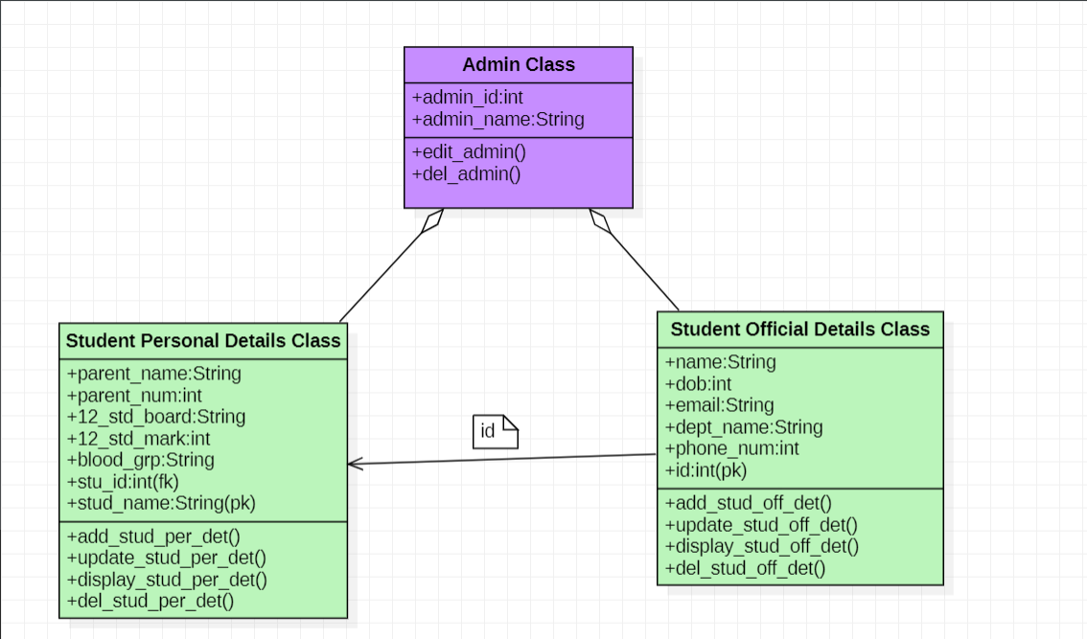

3)SEQUENCE DIAGRAM:

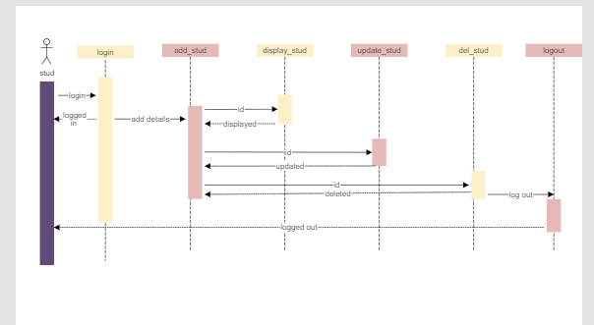

4)STATE ACTIVITY DIAGRAM:

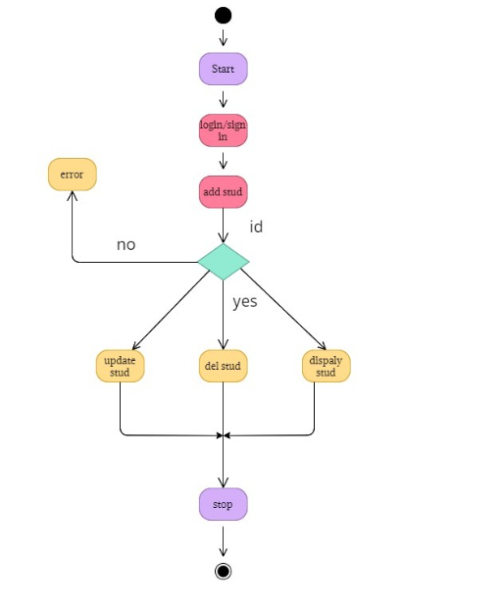

5)ER DIAGRAM:

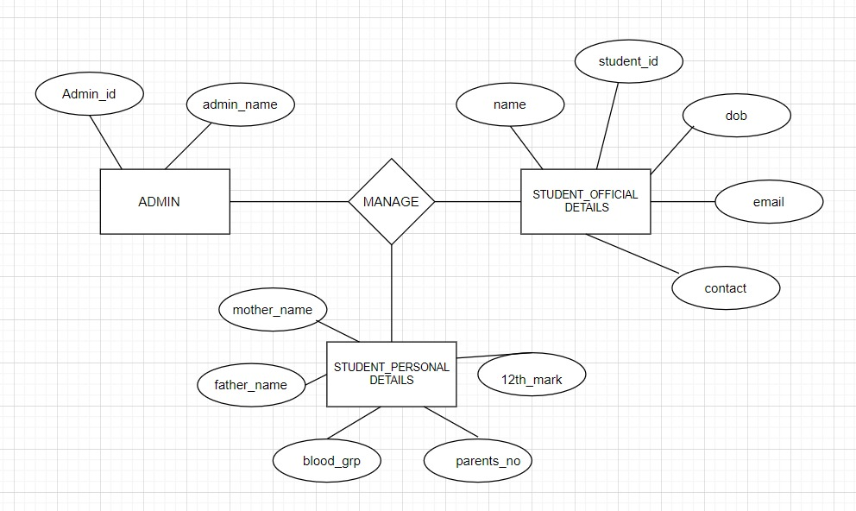

6)ENHANCED ER DIAGRAM:

